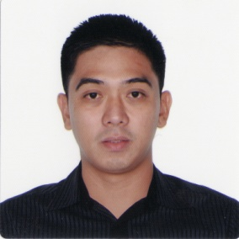
Ferdinand D. Herrera
Senior Lead Technician
09323929561/dondeefch@gmail.com

SUMMARY

A skilled Manufacturing Technician with experience in the production of highly efficient solar cells including process improvement, cycle time optimization, creating new specifications and standards, defect investigation and data gathering with a strong foundation on problem solving tools and methodology.

WORK EXPERIENCE
Sunpower Philippines Manufacturing Limited – FPIP Batangas (June 26, 2007 – October 17, 2012)
Senior Lead Technician for Diffusion Process
• Operates production tools including process monitoring, product testing and qualification as well as performing minor tool repair, calibration and error recovery.
• Led a sub-team which is in charge of eliminating defects that affects product efficiency and quality.
• Conducted trainings focusing on problem solving tools and methodology.
• Participated in the development and implementation of new rules and specifications for both inside and outside the Clean Room.
• Led a team focusing on continuous improvement of the cafeteria’s foods and services.

LEFAR Brides and Debutant –Espanya, Manila (November 2002 – May 2003)
Assistant Coordinator/Waiter
- Participated in the improvement of food quality and services.

Jollibee Foods Corporation – SM City Manila (May – October 2000)
Service Crew – Kitchen and Dining Area

EDUCATION

Mapua Institute of Technology 1998-2007 Bachelor of Science in Electrical Engineering
Pedro Guevara Memorial National High School 1994 – 2008
Sta. Cruz, Laguna

TECHNICAL SKILLS

Problem Solving | : | FMEA, 8D
Manufacturing Software | : | MES, GUI
Operating System | : | Windows XP/7
Metrology Tools | : | Lifetime Tester, Focus Ellipsometer, 4point Probe

PERSONAL INFORMATION

Date of Birth: May 15, 1981
Civil Status: Married
Home: Block 6 Lot 3 Orchard Village Brgy. Banay-banay Cabuyao, Laguna
Email: dondeefch@gmail.com
Contact Number: 09323929561

